HEALTH CARE DATA

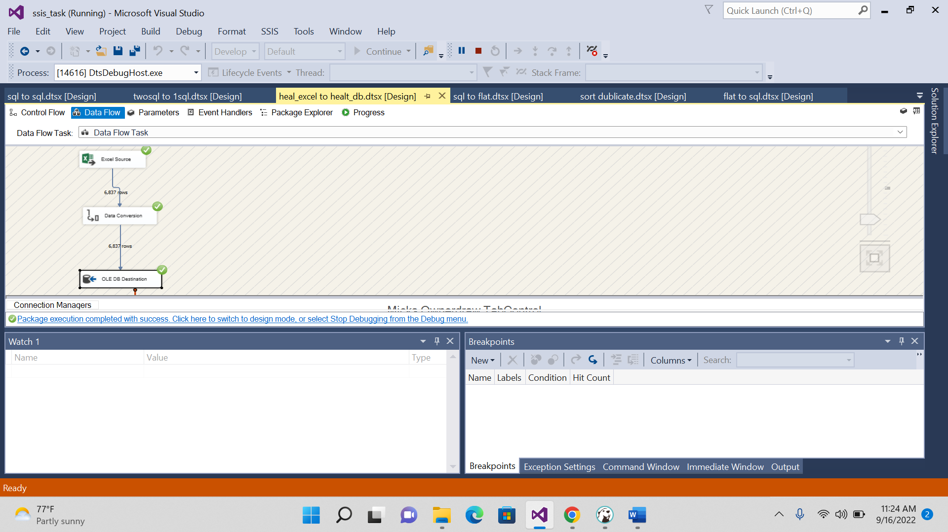

**create** **table** NA_HEALTH100(

Years **int**,

State **varchar**(200),

HAI **varchar**(200),

Operative_Procedure **varchar**(200),

Facility_ID **int** ,

Facility_Name **varchar**(200),

Hospital_Category_RiskAdjustment **varchar**(200),

Hospital_Type **varchar**(200),

County **varchar**(200),

Procedure_Count **int**,

Infection_Count **int**,

Predicted_Infection_Count **float**,

SIR **float**,

SIR_CI_95_Lower_Limit **float**,

SIR_CI_95_Upper_Limit **float**,

Comparison **varchar**(200),

SIR_2015 **float**,

OnTrack_Toward_2020_Goal **varchar**(200),

Notes **varchar**(200)

);

**select** * **from** NA_HEALTH100

output:

